**Exercise 1:**

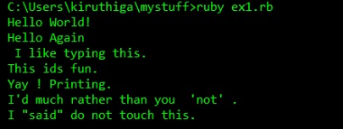

**Exercise 2:**

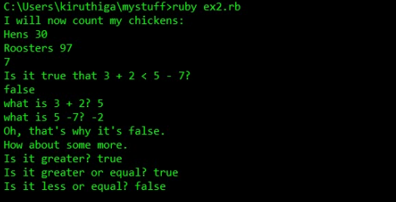

**Exercise 3:**

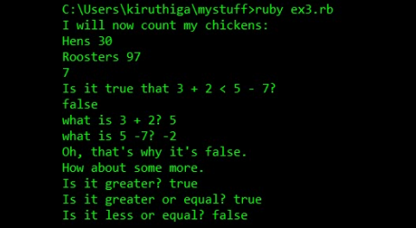

**Exercise 4:**

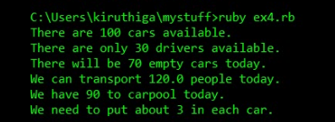

**Exercise 5:**

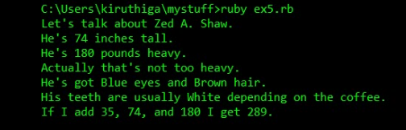

**Exercise 6:**

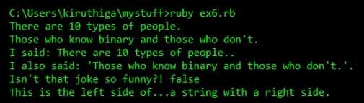

**Exercise 7:**

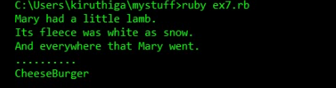

**Exercise 8:**



**Exercise 9:**

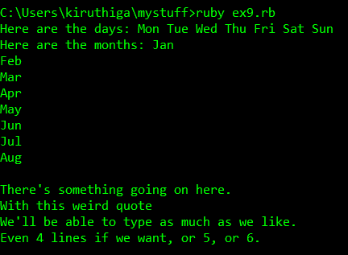

**Exercise 10:**

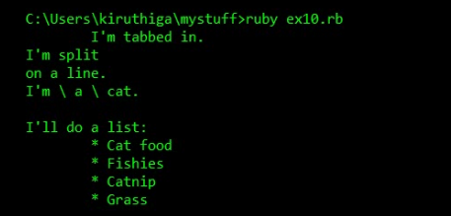

**Exercise 11:**

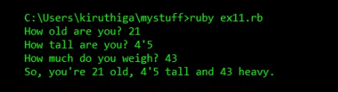

**Exercise 12:**

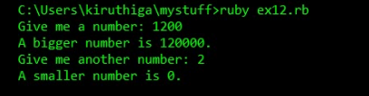

**Exercise 13:**

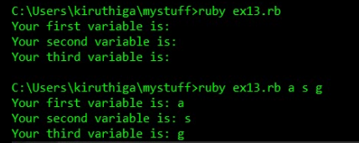

**Exercise 14:**

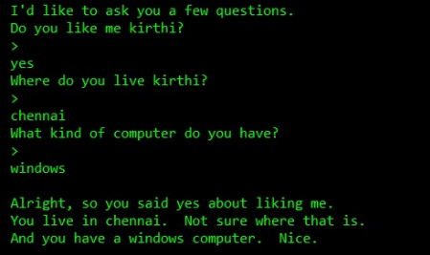

**Exercise 15:**

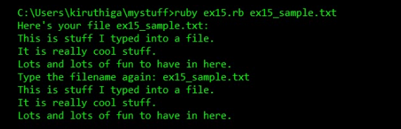

**Exercise 16:**

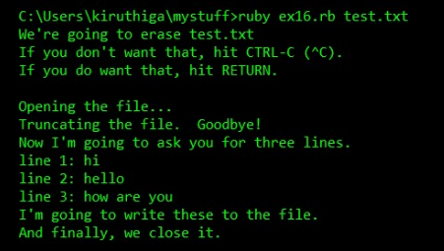

**Exercise 17:**

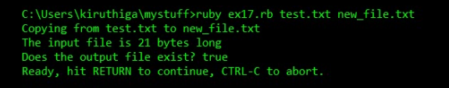

**Exercise 18:**

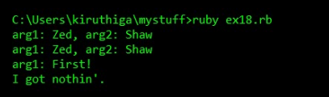

**Exercise 19:**

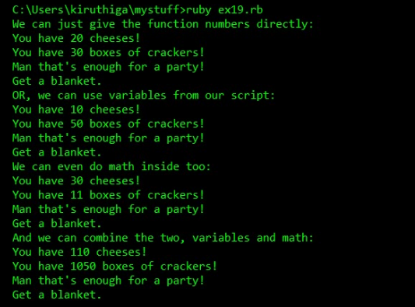

**Exercise 20:**

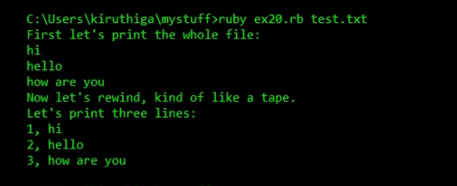

**Exercise 21:**

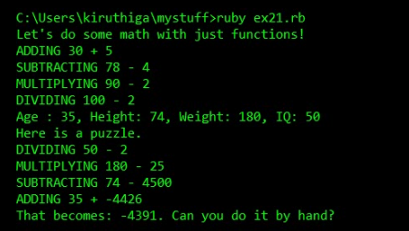

**Exercise 22:**

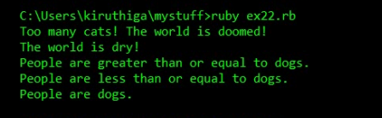

**Exercise 23:**

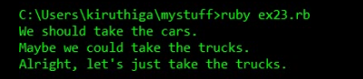

**Exercise 24:**

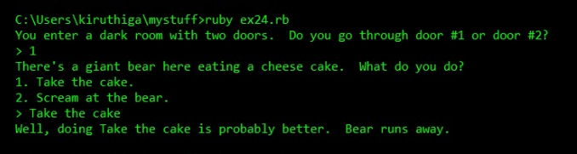

**Exercise 25:**

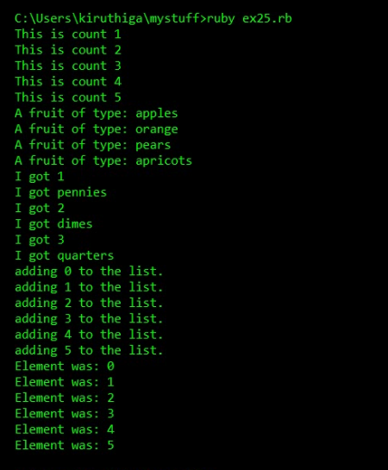

**Exercise 26:**

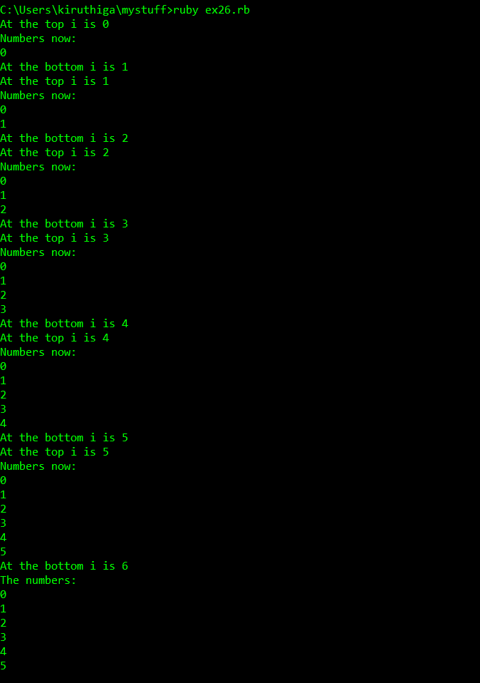

**Exercise 27:**

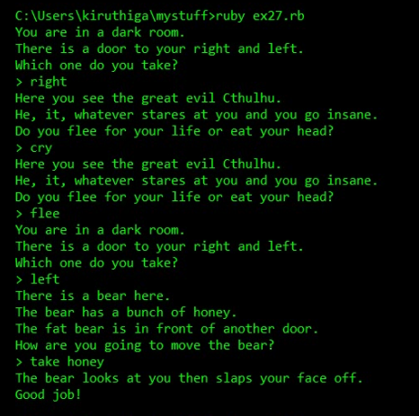

**Exercise 28:**

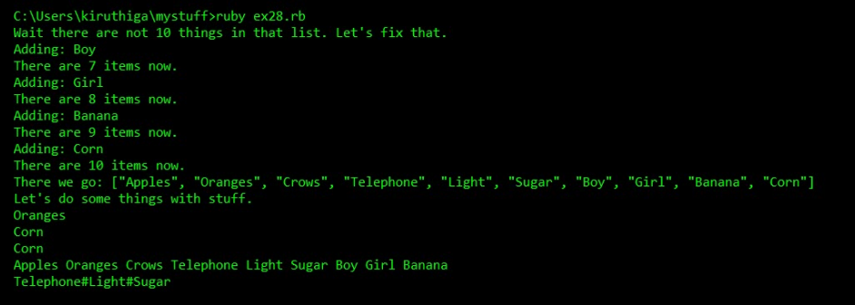

**Exercise 29:**

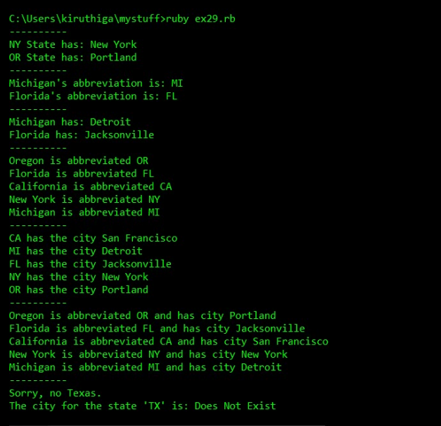

**Exercise 30:**

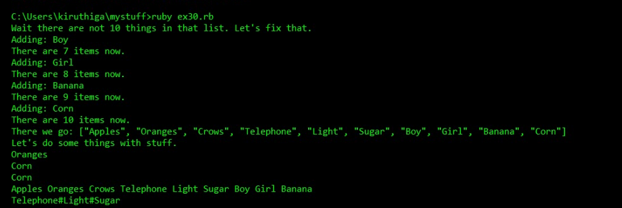

**Exercise 31:**

